Tshegofatso kgatontle seameco
ST10520250

Rosebank College IIE
WEBE5020POE

Project Proposal for Misunderstood World

*This is not a real business. It is a hypothetical business created by me
Organisation Overview:
Misunderstood World is a streetwear brand birthed in the streets of Cape Town in the 2000s for people who always felt like outsiders to the world we all live in, founded by two boys from the cape flats with the mission to bring about confidence within those who always felt left out and a strong vision to empower the silent faces of the youth to elevate.

Website Goals and Objectives:
The website for Misunderstood World is designed to build a strong digital presence for the streetwear brand while connecting with a youth-driven audience that values individuality, creativity, and self-expression. The main goal of the website is to showcase the brand’s unique identity through visually striking clothing collections, engaging content, and a modern user experience that reflects contemporary street culture. Its objectives include increasing brand awareness, driving online sales, promoting new drops and limited-edition releases, and building a loyal online community through interactive features and social media integration. Key Performance Areas for the website include website traffic growth, customer engagement levels, online sales performance, product page conversion rates, social media referrals, customer satisfaction, and brand visibility. Additional focus areas include maintaining fast website performance, ensuring mobile responsiveness, providing secure online transactions, and delivering consistent visual branding across all pages to strengthen the overall customer experience.
Proposed Website Features and Functionality:
Essential features of the website include a homepage, about us, contact page, products page, with a wish list for items that a user would want to save. Other features include a category list for the different types of clothing pieces and a history page that overlays the whole story behind the brand.

Design and User Experience:
The overall design aesthetic and branding is a simple street design with a white and blue shades colour scheme involving a typography with font choices such as Aerosoldier and Funkydori/Groovy style. The layout and design will follow the typical useful bait layout with the UX design wireframe that will allow exploration of UX concepts without committing to final design details. The following image will serve as an example to our design: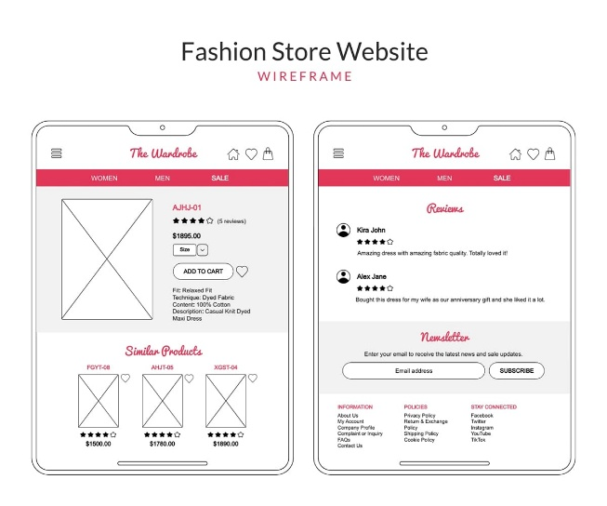
The following image is a representation of the colours to be used on the website:
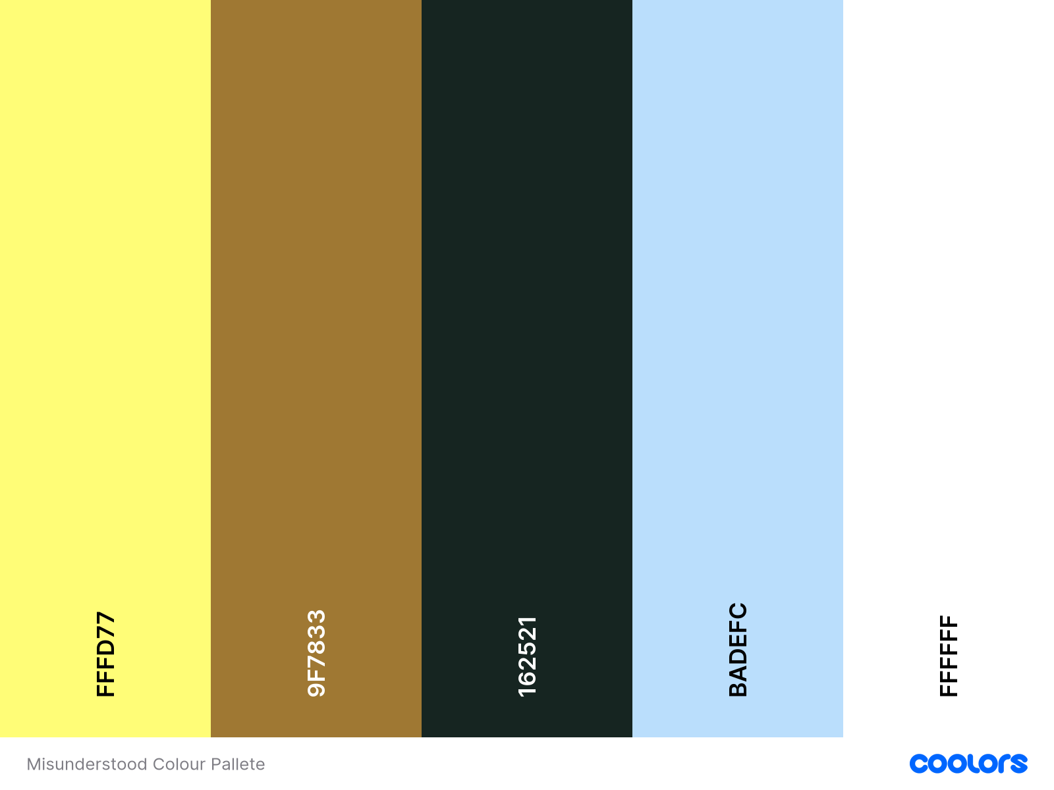
The following image is the type of font that will be used in website to bring life to it:

Technical Requirements:
Infrastructure and Hosting
The Misunderstood World website will be hosted on a reliable cloud-based hosting platform to ensure high availability, scalability, and fast loading speeds. The hosting infrastructure will support increased traffic during product launches and promotional campaigns. The website will use a Content Delivery Network (CDN) to distribute content efficiently to users across different locations, while regular backups and disaster recovery measures will ensure business continuity and data protection.

Performance and Accessibility
The website will be optimized to provide a fast and responsive user experience across desktops, tablets, and mobile devices. Images and media files will be compressed to reduce loading times, and the site will be designed with responsive layouts to adapt to different screen sizes. Accessibility standards will be incorporated to ensure that users with disabilities can navigate and interact with the website through features such as alternative text for images, readable typography, keyboard navigation support, and sufficient colour contrast.

Security and Compliance
Security measures will be implemented to protect customer information and online transactions. The website will use SSL/TLS encryption to secure data transmitted between users and the server. User accounts and payment information will be protected through secure authentication processes and trusted payment gateways. The website will comply with relevant data protection regulations, including the Protection of Personal Information Act (POPIA), ensuring that customer data is collected, stored, and processed responsibly and transparently.

Functional Interfaces
The website will feature intuitive interfaces that allow users to browse products, search for specific items, view detailed product information, and complete purchases efficiently. Functional interfaces will include product catalogues, shopping carts, user account management, secure checkout systems, contact forms, and social media integration. An administrative dashboard will enable staff to manage products, inventory, orders, customer information, and website content effectively.

Ongoing Maintenance
Regular maintenance will be conducted to ensure the website remains secure, functional, and up to date. This includes updating software, plugins, and security patches, monitoring website performance, fixing bugs, and backing up data regularly. Product information, promotional content, and branding elements will be updated as needed to keep the website relevant and engaging. Ongoing maintenance will also involve analysing website analytics and customer feedback to identify opportunities for improvement and enhance the overall user experience.

Timelines and Milestones:
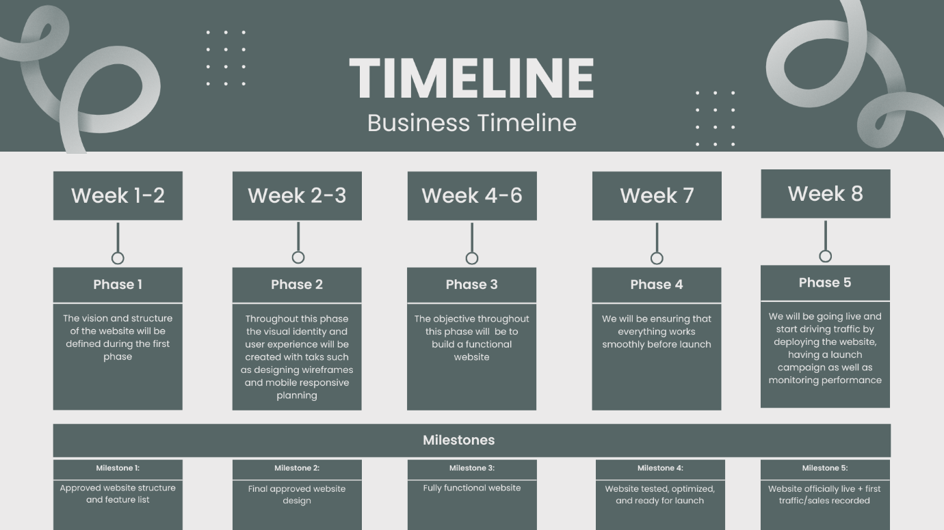

Budget:
- Planning and Strategy
Item | Cost
Market research and Planning | R2,000
Sitemap and feature planning | R1,000
Subtotal | R 3,000

- Design
Item | Cost
Wireframes | R2,000
Full website design | R5,000
Subtotal | R 7,000

- Development
Item | Cost
Website development (front-end + back-end) | R10,000
E-commerce functionality | R4,000
Payment gateway integration | R2,000
Subtotal | R 16,000

- Testing and Optimisation
Item | Cost
Website testing | R1,500
SEO setup | R2,000
Subtotal | R 3,500

- Ongoing Monthly Costs
Item | Cost
Hosting and domain | R150 – R500
Platform subscription | R500 – R1,200
Subtotal | R 650 -R1,700

Total: $±31,200$
Sitemap:
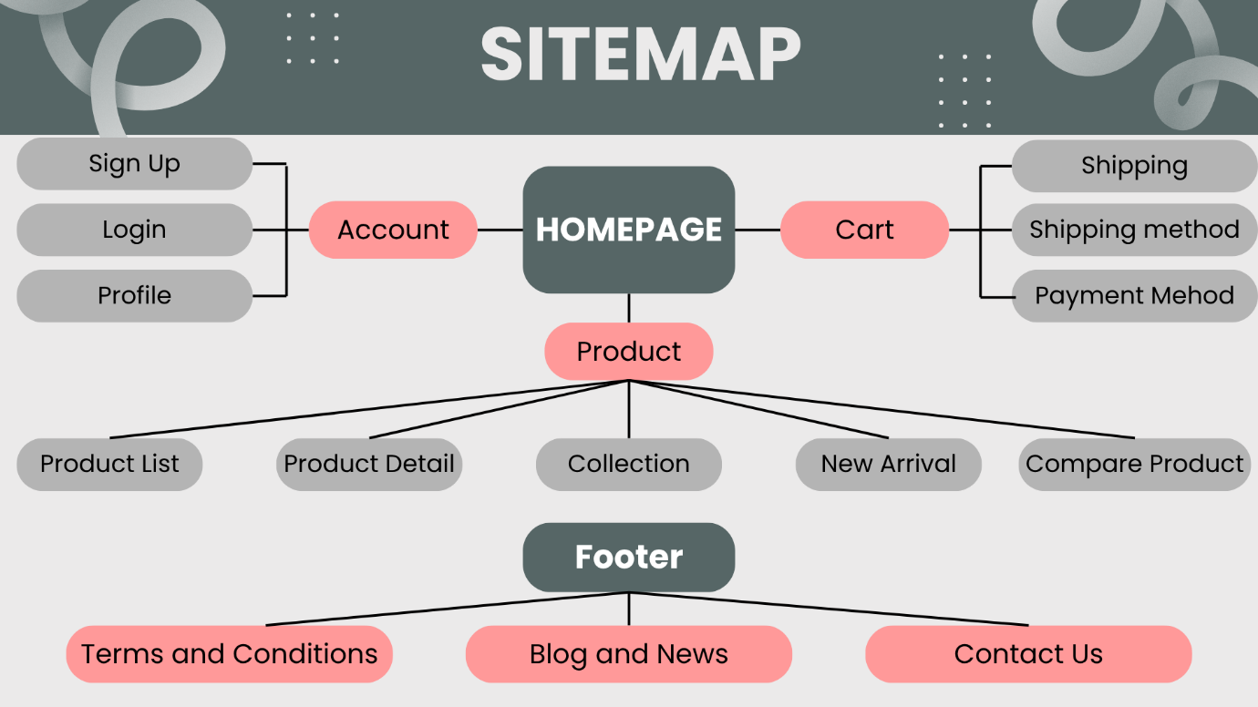

Project Proposal for Two Oceans Aquarium Trust

Organisation Overview:
The Two Oceans Aquarium trust is a non-profit organisation and public benefit organisation that was established in 2019 with the vision for abundant and healthy oceans for life and the mission to inform and inspire all to connect with and protect our ocean and ocean-vulnerable communities through conservation, awareness and research, and education. This organisation targets the South African public, particularly children and young adults, to promote ocean conservation and marine science literacy.

Website Goals and Objectives:
The primary goal of the aquarium website is to serve as an engaging, informative, and user-friendly platform that attracts visitors, promotes marine conservation awareness, and increases overall attendance and revenue. The website aims to provide clear and accessible information about exhibits, ticket pricing, operating hours, and special events, while also offering seamless online booking to improve convenience for users. The key objective would be to promote education and conservation by sharing valuable content about marine life, ecosystems, and ongoing initiatives, while also encouraging user engagement through social media integration, newsletters, and regularly updated content. The website will further support revenue growth by enabling online purchases of tickets, memberships, merchandise, and exclusive experiences, as well as highlighting donation opportunities. Success will be measured using key performance indicators such as website traffic, user engagement (including session duration and bounce rate), conversion rates for ticket sales and sign-ups, online revenue, and user satisfaction, with targets focused on steady traffic growth, increased conversions, and improved overall engagement.

Proposed Website Features and Functionality:
Essential features of the website will include a clear and easy to use navigation structure that allows users to easily access key information. The website will also include an online booking system to enable quick and secure ticket purchases across all devices. The website will also incorporate engaging elements such as image galleries. Educational content, including images, videos and resources about marine life and conservation should be readily available to support learning and awareness. Inclusion of a donations page to support conservation efforts will be made available as well as location details, maps, and inquiry forms.

Design and User Experience:
The overall design aesthetic and branding is a simple oceanic design with a white and blue shades colour scheme involving a typography with font choices such as Aerial, Blue Ocean, Mermaid Bubble, Ocean Drive, etc. The layout and design will follow the typical useful bait layout with the UX design wireframe that will allow exploration of UX concepts without committing to final design details. The following image will serve as an example to our design:
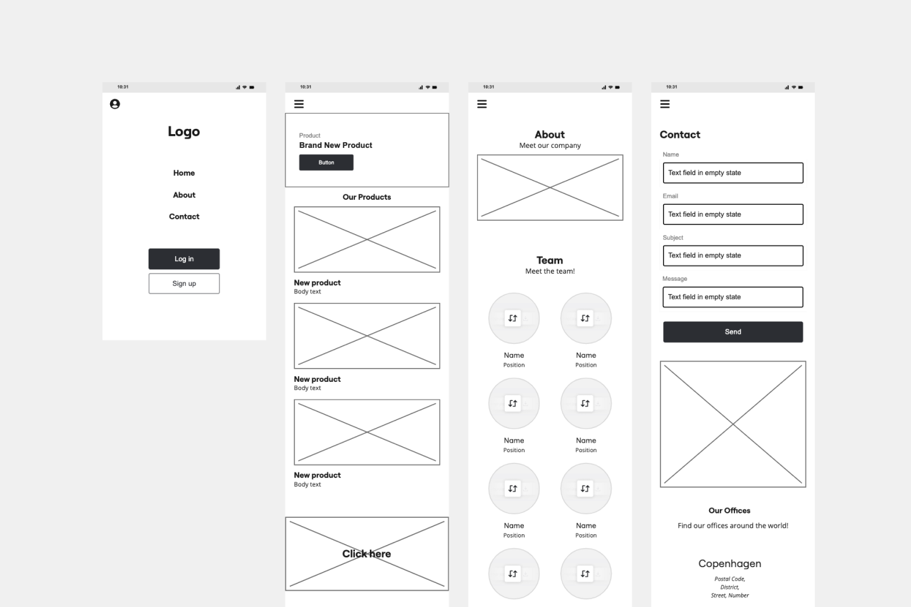
Technical Requirements:
Technical Requirements will include the use of languages such as HTML, JavaScript and CSS. Websites and tools such as vercel.com and GitHub will be used to deploy our website to the internet. cPanel will be used to host our final website. A domain name will be purchased and run through on GoDaddy.com.

Timelines and Milestones:

Budget:
- Planning and Strategy
Item | Cost
Market research and Planning | R2,000.00
Sitemap and feature planning | R1,000.00
Subtotal | R 3,000.00

- Design
Item | Cost
Wireframes | R3,000.00
Full website design | R7,000.00
Subtotal | R 10,000.00

- Development
Item | Cost
Website development (front-end + back-end) | R17,000.00
Ticket booking system | R5,000.00
Payment integration | R3,000.00
Store setup | R2,000.00
Subtotal | R 32,000.00

- Testing and Optimisation
Item | Cost
Website testing | R1,500.00
SEO setup | R2,000.00
Subtotal | R3,500.00

- Ongoing Monthly Costs
Item | Cost
Hosting and domain | R150.00 - R500.00
Platform subscription | R500.00 - R1,200.00
Subtotal | R650.00 - R1,700.00

Total: $±50,200.00$
Sitemap:
